Datasheet
Goat Anti-Mouse IgG H&L (FITC)

Product Unit Cat.#
Goat Anti-Mouse IgG H&L (FITC) 100ug MF201-T
Goat Anti-Mouse IgG H&L (FITC) 1mg MF201-01

【Storage】: Shipped at 4°C. Store at +4°C.
【Storage Buffer】: Preservative: 0.01% Sodium Azide, constituents: 10mg/ml BSA, 0.15M Sodium chloride, 0.02M Potassium phosphate, pH 7.2.

【Background】: This product was prepared from monospecific antiserum by immunoaffinity chromatography using mouse IgG coupled to agarose beads followed by solid phase adsorption(s) to remove any unwanted reactivities. Diaminotriazinylaminofluorescein (DTAF) (Molecular Weight 530 daltons) Absorption Wavelength: 495 nm Emission Wavelength: 528 nm Fluorochrome/Protein Ratio: 3.3 moles FITC per mole of Goat IgG

【Immunogen】: mouse whole molecule.

【Concentration】: 1mg/ml.

【Reactivity】: Mouse.

【Applications】: IHC (PFA fixed), Immunomicroscopy, Flow Cyt, IHC-P, IHC-Fr, ICC/IF, ELISA, WB.

【Isotype】: IgG.

【Purity】: IgG fraction.

【Clone number】: Polyclonal.

【Predicted Molecular Weight】:

【Recommended Dilutions】

ICC/IF: 1/100 - 1/250.

【Reference】: Chapuis C et al. Emergence of sigh rhythmogenesis in the embryonic mouse. J Physiol 592:2169-81 (2014).

【Application Data】

- Immunocytochemistry - Goat polyclonal Secondary Antibody to Mouse IgG - H&L (FITC).

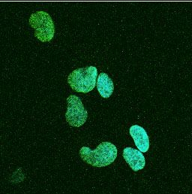

- Immunocytochemistry - Goat polyclonal Secondary Antibody to Mouse IgG - H&L (FITC).

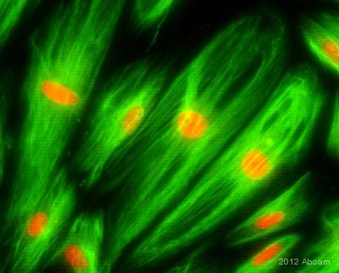

Goat polyclonal Secondary Antibody to Mouse IgG - H&L (FITC) staining vimentin in human colon fibroblasts by ICC/IF (Immunocytochemistry/immunofluorescence).

Please note: All products are "FOR RESEARCH USE ONLY AND ARE NOT INTENDED FOR DIAGNOSTIC OR THERAPEUTIC USE"

