Datasheet
M5 Rabbit IgG

Product Unit Cat.#
M5 Rabbit IgG (1mg/ml) 1mg MF203-01

【Storage】: Shipped at -20°C.

【Background】: Immunoglobulin G (IgG), is one of the most abundant proteins in human serum which constitutes 75% of serum immunoglobulins, IgG is produced by B lymphocytes as a part of our adaptive immune response. The IgG molecule has two separate functions; to bind to the pathogen that elicited the response and to recruit other cells and molecules to destroy the antigen through antibody-dependent cell-mediated cytotoxicity (ADCC) effection.

【Immunogen】: isolated from normal rabbit serum.

【Concentration】: 1mg at 1mg/ml.

【Reactivity】: This antibody has been selected as an isotype control as it has no known specificity.

【Applications】: ELISA Use at an assay dependent dilution.
IP Use at an assay dependent dilution.

【Isotype】: IgG.

【Reference】: 1. Junqueira, Luiz C.; Jose Carneiro (2003). Basic Histology.
2. Mallery DL, McEwan WA, Proc Natl Acad Sci USA. 107(46): 19985-90. 2010.
3. Meulenbroek, A. J.; Zeijlemaker, W.P. (1996).

【Serum Purification】

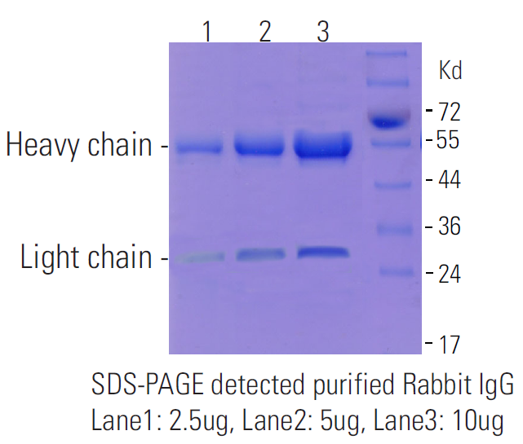

Please note: All products are "FOR RESEARCH USE ONLY AND ARE NOT INTENDED FOR DIAGNOSTIC OR THERAPEUTIC USE"

