M5 Goat Anti-Mouse IgG Alexa Fluor 594 antibody
使用说明书

Product Unit Cat.#
M5 Goat Anti-Mouse IgG Alexa Fluor 594 antibody 100ul MF1137-01

保存条件： Store at -20℃ for one year. Avoid repeated freeze/thaw cycles.

中文名称：AF594标记的山羊抗小鼠IgG H&L

别 名：Goat Anti-Mouse IgG H&L (AF594); Immunoglobulin G;

抗体来源：Goat

克隆类型：Polyclonal

交叉反应：Mouse

产品应用：IF=1:200-1000,Flow-Cyt=1:50-200
not yet tested in other applications.
optimal dilutions/concentrations should be determined by the end user.

性 状：Liquid

浓 度：2.0 mg/ml

免 疫 原：Native Mouse IgG

亚 型：IgG

纯化方法：affinity purified by Protein G, nonspecific adsorbed

缓 冲 液：10 mM TBS (pH=7.4) with 1% BSA, 0.03% Proclin300 and 50% glycerol.

注意事项：This product as supplied is intended for research use only, not for use in human, therapeutic or diagnostic applications.

产品图片
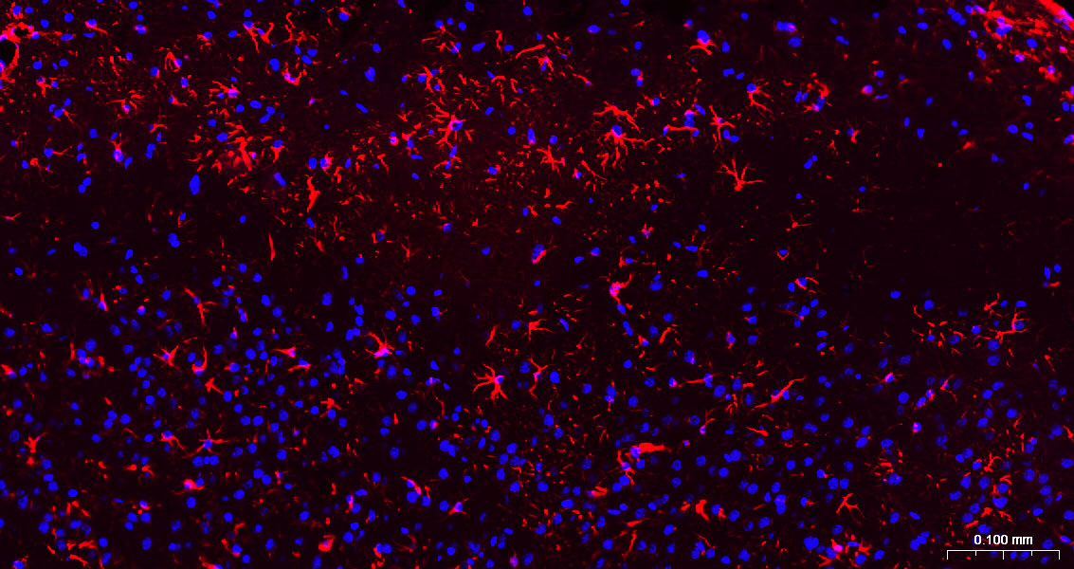

Paraformaldehyde-fixed, paraffin embedded Mouse Cerebrum; Antigen retrieval by boiling in sodium citrate buffer (pH6.0) for 15 min; Antibody incubation with GFAP Monoclonal Antibody, Unconjugated at 1:200 overnight at 4°C. Followed by conjugated Goat Anti-Mouse IgG antibody (Red, MF1137), DAPI was used to stain the cell nuclei.

Please note: All products are "FOR RESEARCH USE ONLY AND ARE NOT INTENDED FOR DIAGNOSTIC OR THERAPEUTIC USE"

